1D, 2D, MultiDimensional Array Assignments

Mandatory

1D Array

1. Refer the code snippet and answer the queries

int main()

{

int array[100];

int *ptr;

// do something

}

Q1: Can pointer be used in Array-style syntax? e.g. ptr[10], ptr[0]

Ans : yes

Q2: Can Array be used in Pointer-style syntax? e.g. *array, *(array + 0), *(array + 10)

Ans : yes

Q3: is ptr++ valid?

Ans : yes

Q4: is array++ valid?

Ans : no

Q5: what is sizeof(array)?

Ans 100*2=200 bytes

Q6: what is sizeof(ptr)?

2. Refer the code snippet below. Comment on the other elements (other than those that are explicitly initialized) of all array variables in code snippet below.

#define MAX 100

int main()

{

int arr[MAX] = {11,22,33};// arr[0]=11,arr[1]=22;arr[2]=33,all other elements from arr[3] to arr[99] is initialized to 0 by default

int arr1[MAX]={0};//arr1[0] is 0 and from arr[1] to arr[99] also initialized to 0

static int arr2[MAX];// since arr2 is static array all its elements are automatically initialized to 0 by default

}

3. Refer the program “array_pointer.c”. Add a function getmax() to find the maximum in the array and call in main() and display the result.

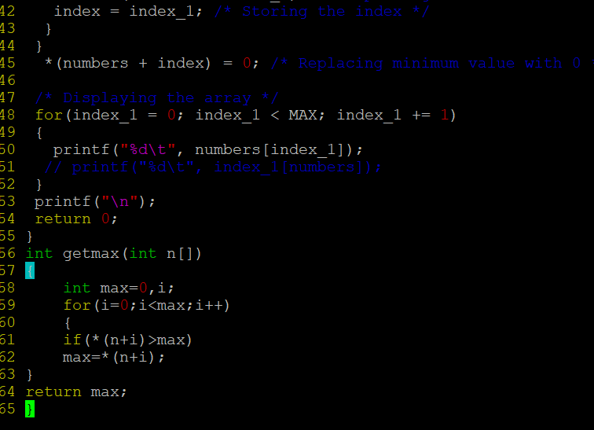

4. Extend the code given below to read N and a start value from the user to perform the given operations.

#define MAX 100

int main()

{

int arr[MAX] = {11,22,33};

}

Add the following functions choosing proper input, output and return.

a. init() - Use the inputs to initialize the first N elements of the array with N consequetive values starting with given start value .

b. update() – increment value of every element in the array

c. display() – display the contents of array

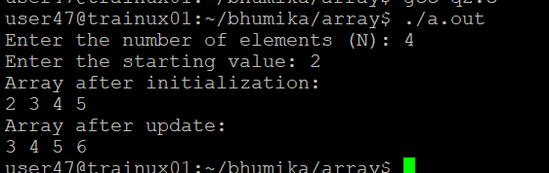

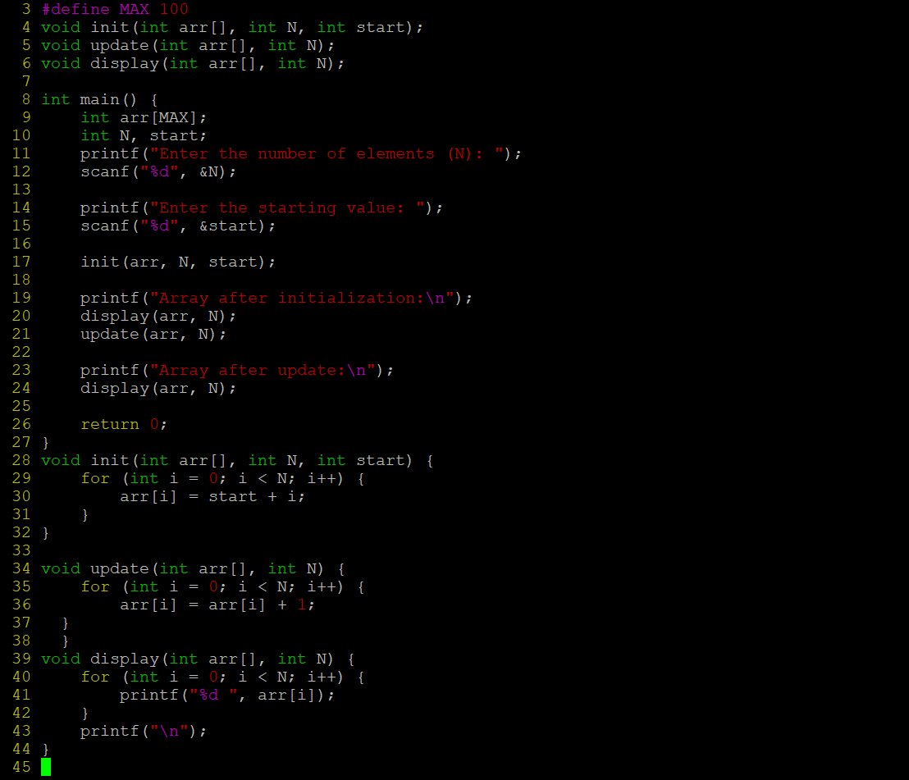

2D, MultiDimensional Arrays

1. Implement sort() to sort a given array. Refer the code snippet below.

int main()

{

char arr[]= “xaybz”;

sort(arr, sizeof(arr)/sizeof(arr[0]);

return 0;

}

2. Refer the code snippet below.

int main()

{

char arr[][3] = {

sort(arr, sizeof(arr)/sizeof(arr[0]);

return 0;

}

Allow user to perform the following operations.

a. init() - initialize the array and return 0

b. search_update() – search for a given element in array and if found update it to given value and return 0 else return 1

c. display() – traverse and display array contents

For the functions, pass array and other required arguments to functions and return as per requirement

